**PIZZA SALES QUERIES**

1. **KPI’S**
2. **TOTAL REVENUE**

select sum(total_price) as total_Revenue from pizza_sales ;

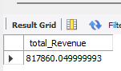

1. **AVERAGE ORDER VALUE**

select sum(total_price) / count(distinct order_id) as Avg_Order_Value from pizza_sales;

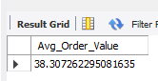

1. **TOTAL PIZZA SOLD**

select sum(quantity) as total_pizza_sold from pizza_sales;

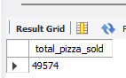

1. **TOTAL ORDER**

select count(distinct order_id) as total_orders from pizza_sales;

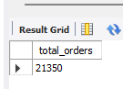

1. **AVERAGE PIZZA PER ORDER**

select sum(quantity) / count(distinct order_id) as avg_pizza_per_order from pizza_sales;

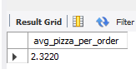

1. **HOURLY TREND FOR ORDER**

select hour(order_time) AS order_hour, count(DISTINCT order_id) AS total_orders

from pizza_sales

group by hour(order_time)

order by hour(order_time);

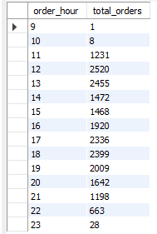

1. **% OF SALES BY PIZZA CATEGORY**

select pizza_category,

CAST(SUM(total_price) AS DECIMAL(10,2)) as total_revenue,

CAST(SUM(total_price) * 100 / (SELECT SUM(total_price) from pizza_sales) AS DECIMAL(10,2)) AS PCT from pizza_sales

group by pizza_category;

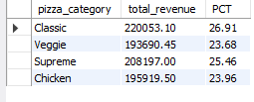

1. **% OF SALES BY PIZZA SIZE**

select pizza_size, CAST(SUM(total_price) AS DECIMAL(10,2)) as total_revenue,

CAST(SUM(total_price) * 100 / (select SUM(total_price) from pizza_sales) AS DECIMAL(10,2)) AS PCT

from pizza_sales

group by pizza_size

order by pizza_size;

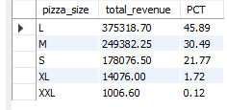

1. **TOP 5 BEST SELLERS BY TOTAL PIZZAS SOLD**

select pizza_name,

SUM(quantity) AS Total_Pizza_Sold

from pizza_sales

group by pizza_name

order by Total_Pizza_Sold DESC

limit 5;

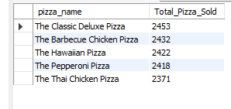

1. **BOTTOM 5 SELLERS BY TOTAL PIZZAS SOLD**

select pizza_name,

SUM(quantity) AS Total_Pizza_Sold

from pizza_sales

group by pizza_name

order by Total_Pizza_Sold ASC

limit 5;

